**Name: Sreelakshmi M Nair**

**Roll No: 40**

**Batch: RMCA**

**Date:18-05-2022**

**Object Oriented Programming LAB**

**Experiment No.: 10**

**Aim**

Area of different shapes using overloaded functions

**Procedures**

**Source Code**

import java.util.Scanner;

public class Area

{

public static void main(String[] args)

{

int ch;

Scanner sc = new Scanner(System.in);

Circle ob = new Circle();

Rectangle obj = new Rectangle();

do

{

System.out.println("\n1.Circle\n2.Rectangle\n3.exit");

System.out.println("Enter your choice:");

ch = sc.nextInt();

switch(ch)

{

case 1 :ob.getdata();

ob.area();

ob.perimeter();

break;

case 2 :obj.getdata();

obj.area();

obj.perimeter();

break;

case 3 :System.out.println("Exited...");

System.exit(0);

}

}while(true);

}

}

interface prop

{

void getdata();

void area();

void perimeter();

}

class Circle implements prop

{

double pi = 3.14;

double r;

Scanner sc = new Scanner(System.in);

public void getdata()

{

System.out.println("Enter the radius of the circle:");

r = sc.nextDouble();

}

public void perimeter()

{

System.out.println("Perimeter of the circle: "+(2*pi*r));

}

public void area()

{

System.out.println("Perimeter of the circle: "+(pi*r*r));

}

}

class Rectangle implements prop

{

double l,b;

Scanner sc = new Scanner(System.in);

public void getdata()

{

System.out.println("Enter the length of the rectangle:");

l = sc.nextDouble();

System.out.println("Enter the breadth of the rectangle:");

b = sc.nextDouble();

}

public void area()

{

System.out.println("Perimeter of a rectangle: "+(l*b));

}

public void perimeter()

{

System.out.println("Perimeter of a rectangle: "+(2*(l+b)));

}

}

**Output**

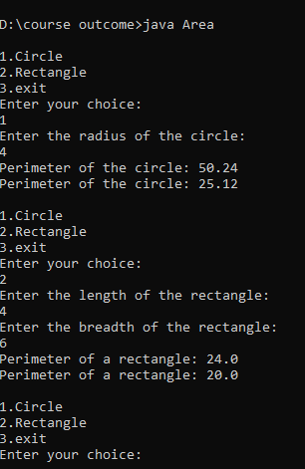

**OBJECT ORIENTED PROGRAMMING LAB**

**Experiment No.: 11**

**Aim**

Create a class ‘Employee’ with data members Empid, Name, Salary, Address and constructors to initialize the data members. Create another class ‘Teacher’ that inherit the properties of class employee and contain its own data members department, Subjects taught and constructors to initialize these data members and also include display function to display all the data members. Use array of objects to display details of N teachers.

.

**Procedure**

**Source Code**

import java.util.Scanner;

class Employee {

int Empid;

String Name;

double Salary;

String Address;

Employee(int no, String na, double sal, String add) {

this.Empid = no;

this.Name = na;

this.Salary = sal;

this.Address = add;

}

}

public class Teacher extends Employee{

String dept;

String subject;

Teacher(int no, String na, double sal, String add, String dep, String sub){

super(no,na,sal,add);

this.dept= dep;

this.subject=sub;

}

void display(){

System.out.println("Employee id: "+Empid);

System.out.println("Name: "+Name);

System.out.println("Salary: "+Salary);

System.out.println("Address: "+Address);

System.out.println("Department: "+dept);

System.out.println("Subject: "+subject);

}

public static void main(String[] args) {

System.out.println("\nEnter the No. of Employee's");

Scanner sc1 = new Scanner(System.in);

int num = sc1.nextInt();

Teacher arr[]=new Teacher[num];

for(int i =0;i<num;i++)

{

Scanner sc =new Scanner(System.in);

System.out.println("\nEnter Employee id: ");

int Empid=sc.nextInt();

System.out.println("\nEnter Employee Name: ");

String Name=sc.next();

System.out.println("\nEnter Salary: ");

double Salary=sc.nextDouble();

System.out.println("\nEnter Address: ");

String Address=sc.next();

System.out.println("\nEnter department: ");

String dept=sc.next();

System.out.println("\nEnter Subject: ");

String subject=sc.next();

arr[i]=new Teacher(Empid,Name,Salary,Address,dept,subject);

}

System.out.println("\n********Informations of all the employee's************");

for(int i=0;i<num;i++){

int j=i+1;

System.out.println("\n"+j+").");

arr[i].display();

}

sc1.close();

}

}

**Output Screenshot**

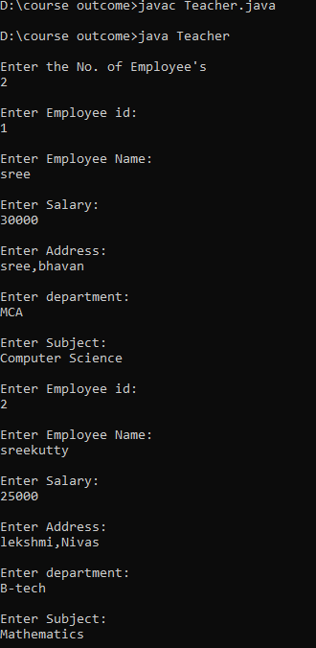

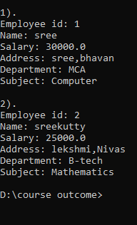

**OBJECT ORIENTED PROGRAMMING LAB**

**Experiment No.: 12**

**Aim**

Create a class ‘Person’ with data members Name, Gender, Address, Age and a constructor to initialize the data members and another class ‘Employee’ that inherits the properties of class Person and also contains its own data members like Empid, Company_name, Qualification, Salary and its own constructor. Create another class ‘Teacher’ that inherits the properties of class Employee and contains its own data members like Subject, Department, Teacherid and also contain constructors and methods to display the data members. Use array of objects to display details of N teachers.

**Procedure**

**Source Code**

import java.util.Scanner;

 class person{

    String Name;

    String Gender;

    String Address;

    int Age;

    person(String name,String gender,String address, int age) {

        this.Name = name;

        this.Gender = gender;

        this.Address = address;

        this.Age = age;

    }

}

class Employee extends person

{

 int Empid;

 String Company_name;

 String Qualification;

 long Salary;

 Employee(String name,String gender,String address, int age,int empid, String company_name, String qualification,long salary)

 {

     super(name,gender,address,age);

     this.Empid= empid;

     this.Company_name=company_name;

     this.Qualification=qualification;

     this.Salary=salary;

 }

}

 public class Teacher2 extends Employee{

     String Subject;

     String Department;

     String Teacherid;

    Teacher2(String name,String gender,String address, int age,int empid, String company_name, String qualification,long salary, String subject, String department, String teacherid){

        super(name,gender,address,age,empid,company_name,qualification,salary);

        this.Subject=subject;

        this.Department=department;

        this.Teacherid=teacherid;

    }

    void display(){

        System.out.println("Name: "+Name);

        System.out.println("Gender: "+Gender);

        System.out.println("Address: "+Address);

        System.out.println("Age: "+Age);

        System.out.println("Employee id: "+Empid);

        System.out.println("Company Name: "+Company_name);

        System.out.println("Qualification: "+Qualification);

        System.out.println("Salary: "+Salary);

        System.out.println("Subject: "+Subject);

        System.out.println("Department: "+Department);

        System.out.println("Teacher id: "+Teacherid);

     }

     public static void main(String[] args) {

        System.out.println("\nEnter the No.of Teacher's");

        Scanner sc1 = new Scanner(System.in);

        int num = sc1.nextInt();

        Teacher2 arr[]=new Teacher2[num];

        System.out.println("\n Enter the Teacher Details\n");

        int x =0,j=0;

        Scanner sc =new Scanner(System.in);

        for(int i=0;i<num;i++)

        {

            x = i+1;

            System.out.println("\n"+x+").");

            System.out.println("\n Name: ");

            String a =sc.next();

            System.out.println("\n Gender: ");

            String b =sc.next();

            System.out.println("\n Address: ");

            String c =sc.next();

            System.out.println("\n Age: ");

            int d =sc.nextInt();

            System.out.println("\n Employee id: ");

            int e =sc.nextInt();

            System.out.println("\n Company name: ");

            String f =sc.next();

            System.out.println("\n Qualification: ");

            String g =sc.next();

            System.out.println("\n Salary: ");

            long h =sc.nextLong();

            System.out.println("\n Subject: ");

            String k =sc.next();

            System.out.println("\n Department: ");

            String l =sc.next();

            System.out.println("\n Teacher Id: ");

            String n =sc.next();

            arr[i]=new Teacher2(a,b,c,d,e,f,g,h,k,l,n);

        }

        sc.close();

        System.out.println("\n********Informations of all the Teacher's************");

        for(int i=0;i<num;i++){

            j=i+1;

            System.out.println("\n"+j+").");

            arr[i].display();

     }

     sc1.close();

     }

 }

**Output Screenshot**

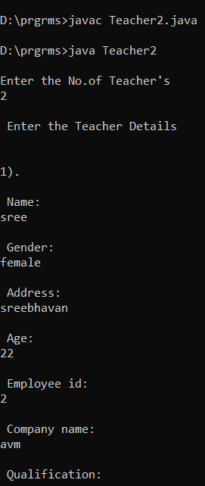

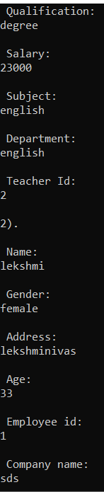

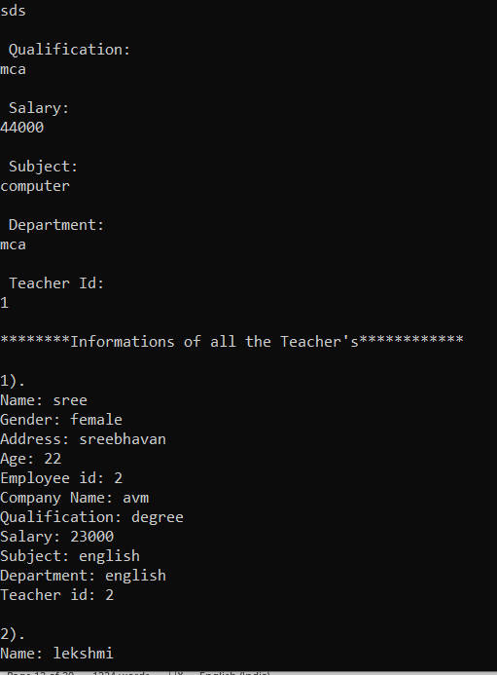

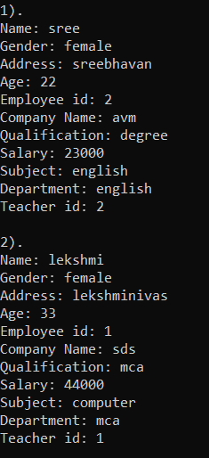

**OBJECT ORIENTED PROGRAMMING LAB**

**Experiment No.: 13**

**Aim**

Write a program has class Publisher, Book, Literature and Fiction. Read the information and print the details of books from either the category, using inheritance..

**Procedure**

**Source Code**

import java.util.Scanner;

public class bookDetails{

public static void main(String[] args) {

System.out.println("\nEnter the No. of Literature Books");

Scanner sc1 = new Scanner(System.in);

int num = sc1.nextInt();

Literature arr[]=new Literature[num];

System.out.println("\n Enter the Literature Book Details\n");

int x = 0,j=0;

Scanner sc =new Scanner(System.in);

for(int i =0;i<num;i++)

{

x = i +1;

System.out.println("\n"+x+").");

System.out.println("\n Book : ");

String boo =sc.next();

System.out.println("\n Publisher: ");

String pub =sc.next();

arr[i]=new Literature(boo,pub);

}

System.out.println("\nEnter the No. of Fiction Books");

int num1 = sc1.nextInt();

Fiction arr1[]=new Fiction[num1];

System.out.println("\n Enter the Fiction Book Details\n");

int x1 = 0,j1=0;

for(int i =0;i<num1;i++)

{

x1 = i +1;

System.out.println("\n"+x1+").");

System.out.println("\n Book : ");

String boo =sc.next();

System.out.println("\n Publisher: ");

String pub =sc.next();

arr1[i]=new Fiction(boo,pub);

}

sc.close();

sc1.close();

System.out.println("\n********Informations of all the Literature Books************");

for(int i=0;i<num;i++){

j=i+1;

System.out.println("\n"+j+").");

arr[i].display();

}

System.out.println("\n********Informations of all the Fiction Books************");

for(int i=0;i<num1;i++){

j1=i+1;

System.out.println("\n"+j1+").");

arr1[i].display();

}

sc1.close();

}

}

class Publisher{

String publisher;

Publisher(String pub){

this.publisher=pub;

}

}

class Book extends Publisher{

String book;

Book(String pub,String boo){

super(pub);

book=boo;

}

}

class Literature extends Book{

String category;

Literature(String pub, String boo){

super(pub, boo);

}

void display(){

System.out.println("Publisher :"+publisher);

System.out.println("Book :"+book);

}

}

class Fiction extends Book{

Fiction(String pub, String boo){

super(pub, boo);

}

void display(){

System.out.println("Publisher :"+publisher);

System.out.println("Book :"+book);

}

}

**Output Screenshot**

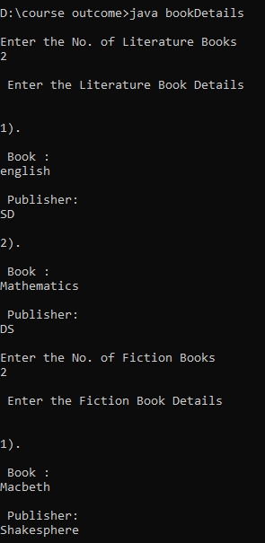

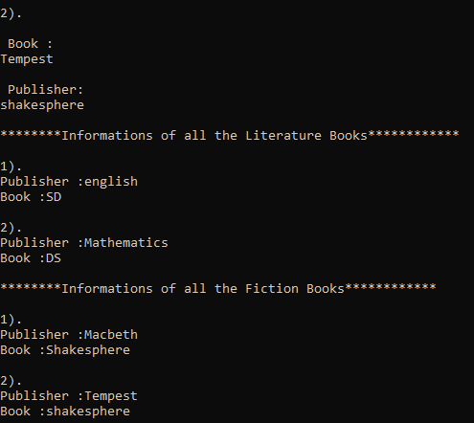

**Experiment No.: 14**

**Aim**

Create classes Student and Sports. Create another class Result inherited from Student and Sports. Display the academic and sports score of a student.

**Procedure**

**Source Code**

class sports{

String sport;

int Rating;

sports(String spo, int ra){

sport = spo;

Rating = ra;

}

}

class student extends sports{

String Grade;

double Overall_per;

student(String spo, int ra,String gd, double per ){

super(spo, ra);

Grade = gd;

Overall_per = per;

}

}

public class result extends student {

result(String spo, int ra,String gd, double per ){

super(spo, ra, gd, per);

}

void display(){

System.out.println("\nSports Details of Student");

System.out.println("Sport :"+sport);

System.out.println("Rating :"+Rating);

System.out.println("\nAcademic Details of Student");

System.out.println("Academic Grade :"+Grade);

System.out.println("Overall percentage :"+Overall_per);

}

public static void main(String[] args) {

Scanner sc =new Scanner(System.in);

System.out.println("\nEnter the Sports Details of Student");

System.out.println("\n Sport: ");

String a =sc.next();

System.out.println("\n Sport Rating out of 10: ");

int b =sc.nextInt();

System.out.println("\nEnter the Sports Details of Student");

System.out.println("\n Academic Grade: ");

String c =sc.next();

System.out.println("\n Overall percentage: ");

double d =sc.nextDouble();

sc.close();

result obj= new result(a,b,c,d);

obj.display();

}

}

**Output Screenshot**

